A
Mini project Report On
Nutrient Deficiency Detection And Classifications of Coffee Plants
Submitted in partial fulfillment of the requirements for the award of
BACHELOR OF TECHNOLOGY
In
COMPUTER SCIENCE AND ENGINEERING
By
Kurugodu Sai Vikas (24TQ1A05D0)
Pedagani Sravani (24TQ1A05H3)
Maddula Ajay Reddy (24TQ1A05H5)
Panga Vishnu (24TQ1A05H0)
Under the Esteemed Guidance of
Dr.BADARLA ANIL

Assistant Professor

DEPARTMENT OF COMPUTER SCIENCE AND ENGINEERING

SIDDHARTHA INSTITUTE OF TECHNOLOGY AND SCIENCES
(UGC - AUTONOMOUS)

(Approved by AICTE , New Delhi & Affiliated to JNTUH , Hyderabad) Accredited by NBA and NAAC with ‘A+’ Grade
Narapally, Korremula Road, Ghatkesar, Medchal Malkajgiri(Dist)- 500088 2025 – 2026

SIDDHARTHA INSTITUTE OF TECHNOLOGY AND SCIENCES 
(Approved by AICTE ,Affiliated to JNTUH , Hyderabad v Accredited by NBA and NAAC with ‘A+’ Grade
Narapally, Korremula Road, Ghatkesar, Medchal Malkajgiri(Dist)- 500088

CERTIFICATE

This is to certify that this Project Report entitled
Being Submitted
Nutrient Deficiency Detection And Classification of Coffee Plants by using Deep Learning

By
Kurugodu Sai Vikas (24TQ1A05D0)
Pedagani Sravani (24TQ1A05H3)
Maddula Ajay Reddy (24TQ1A05H5)
Panga Vishnu (24TQ1A05H0)
In partial fulfillment for the award of the degree of Bachelor of Technology in Computer Science and Engineering, Jawaharlal Nehru Technological University Hyderabad, is a record of bonafide work carried out under my guidance and supervision. The results embodied in this project report have not been submitted to any other University or Institute for the award of any Degree or Diploma.
Guide : Head of the Department:
Dr.BADARLA ANIL DR.V. SUMALATHA
Assistant Professor, Department of CSE HOD, Department of CSE

Internal Examiner External Examiner
DECLARATION

We, Sravani, Sai Vikas, Ajay Reddy and Vishnu here by declare that the results embodied in this project dissertation entitled “Nutrient deficiency detection and classification of coffee plants” is carried out by us during the year 2025 – 2026 in partial fulfillment of the award of Bachelor of Technology in Computer Science and Engineering from Siddhartha Institute of Technology & Sciences. It is an authentic record carried out by us the guidance of Mr.DR.Bardarla Anil Assistant Professor, Department of Computer Science and Engineering

By

Kurugodu Sai Vikas (24TQ1A05D0)
Pedagani Sravani (24TQ1A05H3)
Maddula Ajay Reddy (24TQ1A05H5)
Panga Vishnu (24TQ1A05H0)

ACKNOWLEDGEMENT

Any endeavor in the field of development is a person’s intensive activity. A successful project is a fruitful culmination of efforts by many people, some directly involved and some others who have quietly encouraged and supported.
Salutation to be beloved and highly esteemed institute SIDDHARTHA INSTITUTE OF TECHNOLOGY AND SCIENCES for grooming us into Computer Science and Engineering( graduate, We wish to thank PRINCIPAL Dr.M.JANARDHAN for providing a great learning environment.
We wish to express profound gratitude to Dr.V.SUMALATHA, Assistant Professor and HEAD OF DEPARTMENT, COMPTER SCIENCE ENGINEERING, for his continuous encouragement to ensure successful results in all my endeavors.
We would like to thank Mr.DR.Bandarla Anil, Department of COMPUTER SCIENCE ENGINEERING, who patiently guided and helped us throughout our Research project.

By
kurugodu Sai Vikas (24TQ1A05D0)
Pedagani Sravani (24TQ1A05H3)
Maddula Ajay Reddy (24TQ1A05H5)
Panga Vishnu (24TQ1A05H0)

Table of Contents:
Title | Page no
Abstract | 6
List of figures | 5
Introduction | 7
Literature Review | 8-10
Model Architecture | 11-12
Methodology | 12-15
Results | 15-17
Discussions | 17-18
Feature Extraction | 18-19
Key contribution | 19-20
Advantages | 20-21
Limitations | 21-22
Applications | 23-24
Conclusion | 24
Future Work | 24-25
References | 26-28

List of Figures:
Figure no. | Page no.
Figure(i) | 11
Figure(ii) | 12
Figure(iii) | 16
Figure(iv) | 17
Figure(v) | 18

Abstract:
This paper presents a deep learning-based approach for the detection and classification of nutrient deficiencies in coffee plant leaves using transfer learning. The proposed system utilizes the EfficientNetB4 model as the core architecture, leveraging pre-trained ImageNet weights for effective feature extraction. A publicly available Kaggle dataset of coffee leaf images, comprising healthy and nutrient-deficient classes, is used for training and evaluation. The images are preprocessed through resizing, normalization, and augmentation techniques to improve data diversity and model generalization. The model is trained using the Adam optimization algorithm and categorical cross-entropy loss function, followed by fine-tuning of selected layers to enhance performance. Experimental results demonstrate high classification accuracy with improved precision and recall compared to traditional CNN models. The system effectively predicts multiple nutrient deficiencies such as nitrogen, boron, and potassium, making it suitable for real-time agricultural applications. The proposed approach offers a robust, efficient, and scalable solution for precision farming and automated plant health monitoring.

Keywords
- Nutrient Deficiency Detection
- EfficientNetB4
- Transfer Learning
- Coffee Leaf Classification
- Deep Learning
- Image Processing
- Precision Agriculture

Introduction:
Agriculture plays a vital role in the global economy, and crop health monitoring is essential for ensuring high productivity and sustainable farming. Among various crops, coffee is one of the most widely consumed beverages worldwide, and its cultivation significantly contributes to the livelihoods of millions of farmers. However, coffee plants are highly susceptible to nutrient deficiencies, which can adversely affect their growth, yield, and quality. Early detection and classification of these deficiencies are crucial for timely intervention and effective crop management.
Traditionally, nutrient deficiency identification in plants has been carried out through manual inspection by agricultural experts. This approach is time-consuming, labor-intensive, and often prone to human error, especially when symptoms are subtle or visually similar. Moreover, in rural or remote areas, access to expert knowledge is limited, which further complicates the problem. Therefore, there is a growing need for automated, accurate, and efficient systems that can assist farmers in identifying plant health issues.
With the rapid advancement of Artificial Intelligence (AI) and Deep Learning, significant improvements have been made in image-based plant disease detection. Convolutional Neural Networks (CNNs), in particular, have shown remarkable performance in image classification tasks due to their ability to automatically extract relevant features from raw images. By leveraging these technologies, it is possible to develop intelligent systems capable of detecting nutrient deficiencies in coffee leaves with high accuracy.
In this project, a deep learning-based approach is proposed for the detection and classification of nutrient deficiencies in coffee plants. The model utilizes transfer learning with EfficientNetB4, a state-of-the-art CNN architecture known for its efficiency and performance. By using a pre-trained model and fine-tuning it on a coffee leaf dataset, the system can effectively learn complex patterns associated with different types of nutrient deficiencies.
The dataset used in this study is collected from publicly available sources such as Kaggle, containing images of healthy and deficient coffee leaves. These images are preprocessed and augmented to improve model generalization and robustness. The trained model is then evaluated using various performance metrics such as accuracy, precision, recall, and loss.
The primary objective of this project is to develop a reliable and efficient system that can assist farmers and agricultural professionals in identifying nutrient deficiencies at an early stage. This not only helps in improving crop yield and quality but also reduces the excessive use of fertilizers, promoting sustainable agricultural practices

Literature Review:
Soares et al., [1], 2026, presented a systematic review on machine learning and deep learning applications for foliar nutritional deficiency detection, highlighting the effectiveness of CNN-based models while addressing challenges such as dataset limitations, environmental variability, and real-time deployment in precision agriculture systems.
Poolakanda Somanna, [2], 2025, developed a deep learning-based system for detecting and classifying diseases in Arabica coffee leaves, achieving accurate results and demonstrating the potential of automated image-based analysis for improving crop monitoring and early disease diagnosis.
Mridul et al., [3], 2025, conducted a comparative evaluation of pretrained and custom CNN models for plant disease recognition, showing that optimized architectures significantly improve classification accuracy and performance across diverse agricultural datasets.
Bacuna and Ballera, [4], 2025, proposed an EfficientNet-based leaf classification model to optimize intercropping farm methods, demonstrating improved accuracy and efficiency in plant condition monitoring and supporting better decision-making in modern agricultural practices.
Chavan, [5], 2025, presented a comprehensive survey on crop disease detection using deep learning, emphasizing advancements in CNN architectures, challenges in data acquisition, and the importance of robust, scalable solutions for real-time agricultural applications.
Goyal et al., [6], 2025, introduced a smart intercropping system utilizing hyperspectral imaging and hybrid deep learning models, achieving precise detection of plant diseases and enhancing agricultural productivity through improved monitoring and analysis techniques.
Winarno et al., [7], 2025, conducted a comparative study of various CNN architectures, demonstrating performance improvements in image classification tasks and highlighting the significance of selecting appropriate deep learning models for agricultural image analysis.
Alahi et al., [8], 2025, developed an image-based system for detecting diseases in bean plants, achieving accurate classification results and demonstrating the effectiveness of deep learning approaches in monitoring plant health and supporting agricultural decision-making.
Rosadi and Hakim, [9], 2023, applied CNN-based EfficientNet models for classifying coffee leaf diseases, achieving high accuracy and validating the suitability of deep learning techniques for automated disease detection in agricultural environments.
Pratap and Kumar, [10], 2023, proposed a customized EfficientNetB4 model for multiclass classification of chili leaf diseases, achieving high precision and demonstrating the model’s capability in extracting complex features for accurate plant disease identification.
Puspasari et al., [11], 2024, proposed an EfficientNet-based model integrated with dual-convolution spatial attention (DCCBAM) for sugarcane disease classification, improving feature extraction and classification accuracy, and demonstrating the effectiveness of attention mechanisms in enhancing deep learning model performance.
Sharma et al., [12], 2023, developed modified deep learning architectures for segmenting disease regions in rice leaves, achieving improved precision and localization accuracy, which helps in better identification of infected areas and supports advanced plant disease analysis systems.
Vera et al., [13], 2024, introduced an optimized convolutional neural network with enhanced training strategies for classifying Persea americana, achieving improved accuracy and robustness, and demonstrating its applicability in agro-industrial environments for plant classification tasks.
Ranga et al., [14], 2024, applied EfficientNet for detecting diseases in peach leaves, achieving high classification accuracy and demonstrating the effectiveness of deep learning models in identifying plant diseases through image-based analysis.
Bacuna and Ballera, [15], 2025, developed an EfficientNet-based leaf classification model to optimize intercropping farm methods, improving classification performance and supporting intelligent agricultural decision-making through accurate plant condition monitoring.
Lelis et al., [16], 2023, conducted a comparative analysis of different convolutional neural network architectures for coffee leaf rust detection, identifying models with better accuracy and computational efficiency suitable for real-time agricultural applications.
Goyal et al., [17], 2025, proposed a smart intercropping system combining hyperspectral imaging and hybrid deep learning techniques, achieving precise detection of plant diseases and enhancing productivity through advanced monitoring in precision agriculture.
Balafas et al., [18], 2023, reviewed machine learning and deep learning techniques for plant disease detection, highlighting the effectiveness of CNN-based models, challenges in dataset availability, and future research directions in agricultural automation systems.
Maula, [19], 2025, proposed a machine learning-based system for detecting diseases in cocoa plantations, demonstrating improved classification accuracy and highlighting its economic viability for large-scale agricultural monitoring and management.
Santos, [20], 2022, applied convolutional neural networks to classify coffee fruit maturity stages, achieving reliable results and demonstrating the usefulness of deep learning in agricultural quality assessment and crop management.
Calderón-Mosilot et al., [21], 2025, developed a deep learning-based system for detecting nutritional deficiencies in coffee plants using image analysis, achieving high classification accuracy under uncontrolled environmental conditions and supporting real-world agricultural applications.
Randive et al., [22], 2025, proposed a deep learning model for detecting nutrient deficiencies in coffee leaves, demonstrating effective classification performance and emphasizing the importance of automated systems for early diagnosis in precision agriculture.
Istoningtyas et al., [23], 2025, introduced an automated detection system for coffee leaf nutrient deficiencies, improving agricultural productivity through early diagnosis and enabling efficient decision-making using advanced deep learning techniques.
Chelanami and Kalaburgi, [24], 2025, developed a deep learning model for detecting and classifying nutritional deficiencies in coffee plants, achieving high accuracy and supporting precision agriculture practices through automated plant health monitoring.
Calderón-Mosilot et al., [25], 2025, presented an automated deep learning framework for identifying nutritional deficiencies in coffee plants, demonstrating robust performance and highlighting its applicability in real-world agricultural environments.

Model Architecture:
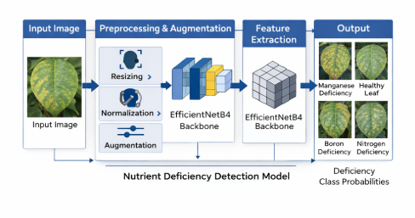
Figure(1): The proposed Nutrient Deficiency Detection Model follows a structured pipeline consisting of four main stages: input image acquisition, preprocessing and augmentation, feature extraction using EfficientNetB4, and classification. Initially, the model receives an input image of a coffee leaf, which is then processed to ensure consistency and quality.In the preprocessing and augmentation stage, the image is resized, normalized, and augmented using techniques such as rotation and flipping to enhance dataset diversity and improve model generalization. These steps help in reducing noise and improving the robustness of the model.The processed image is then passed to the EfficientNetB4 backbone, which acts as the core feature extractor. This model utilizes transfer learning by leveraging pre-trained weights from ImageNet, enabling it to extract meaningful and high-level features from the input image efficiently.

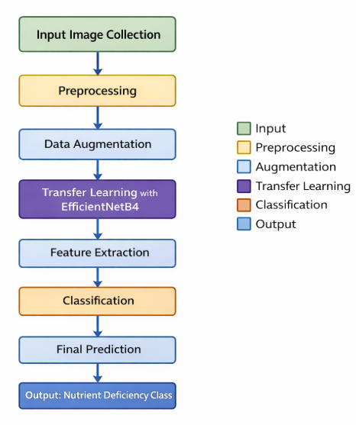
Figure(2): The flowchart illustrates the step-by-step process involved in the detection and classification of nutrient deficiencies in coffee leaves. The process begins with the collection of an input image of a coffee leaf, which serves as the initial data for the system.In the preprocessing stage, the input image is resized and normalized to ensure uniformity and improve image quality. This step helps in reducing noise and preparing the data for further processing. Following preprocessing, data augmentation techniques such as rotation, flipping, and scaling are applied to increase dataset diversity and enhance model generalization.

Methodology
Step 1: Image Preprocessing
The input coffee leaf images are resized and normalized to ensure uniformity before feeding into the model.
Formula:
$$X_{norm}=\frac{X}{255}----eq(i)$$
Where:
$X$– Original pixel value
$X_{norm}$– Normalized pixel value
Step 2: Data Augmentation
Data augmentation techniques such as rotation and flipping are applied to increase dataset diversity and improve generalization.
Formula:
$$\left[\begin{aligned}x^{'} \\ y^{'}\end{aligned}\right]=\left[\begin{matrix}\cos{θ} & -sin⁡θ \\ \sin{θ} & \cos{θ}\end{matrix}\right]\left[\begin{aligned}x \\ y\end{aligned}\right]----eq(ii)$$
Where:
$\left(x , y\right)$– Original coordinates
$\left(x^{'} , y^{'}\right)$– Transformed coordinates
$θ$– Rotation angle

Step 3: Feature Extraction using EfficientNetB4
The EfficientNetB4 model extracts high-level features from input images using compound scaling.
Formula:
$$Depth=α^{ϕ},Width=β^{ϕ},Resolution=γ^{ϕ}----eq(iii)$$
Where:
$α$– Depth scaling coefficient
$β$– Width scaling coefficient
$γ$– Resolution scaling coefficient
$ϕ$– Scaling factor

Step 4: Transfer Learning
Pre-trained weights are used to extract meaningful features, reducing training time and improving performance.
Formula:
$$f\left(x\right)=Wx+b----eq(iv)$$
Where:
$x$– Input feature vector
$W$– Weight matrix
$b$– Bias term
$f(x)$– Extracted feature output

Step 5: Fine-Tuning
Selected layers of the model are unfrozen and retrained to adapt to coffee leaf nutrient deficiency features.
Formula:
$$W^{'}=W-η⋅∇L----eq(v)$$
Where:
$W^{'}$– Updated weights
$η$– Learning rate
$∇L$– Gradient of loss function

Step 6: Classification using Softmax
The Softmax function converts model outputs into probability distributions for multi-class classification.
Formula:
$$P\left(y_{i}\right)=\frac{e^{z_{i}}}{\sum_{j=1}^{n}{e^{z_{j}}}}----eq(vi)$$
Where:
$z_{i}$– Logit for class $i$
$P(y_{i})$– Probability of class $i$
$n$– Number of classes

Step 7: Loss Function and Model Evaluation
The model is trained using categorical cross-entropy loss and evaluated using performance metrics.
Formula (Loss Function):
$$L=-\sum_{i=1}^{n}{y_{i}}\log\left({\hat{y}}_{i}\right)----eq(vii)$$
Formula (Accuracy):
$Accuracy=\frac{TP+TN}{TP+TN+FP+FN}----eq$(viii)
Where:
$y_{i}$– True label
${\hat{y}}_{i}$– Predicted value
$TP,TN,FP,FN$– Confusion matrix components

Result:
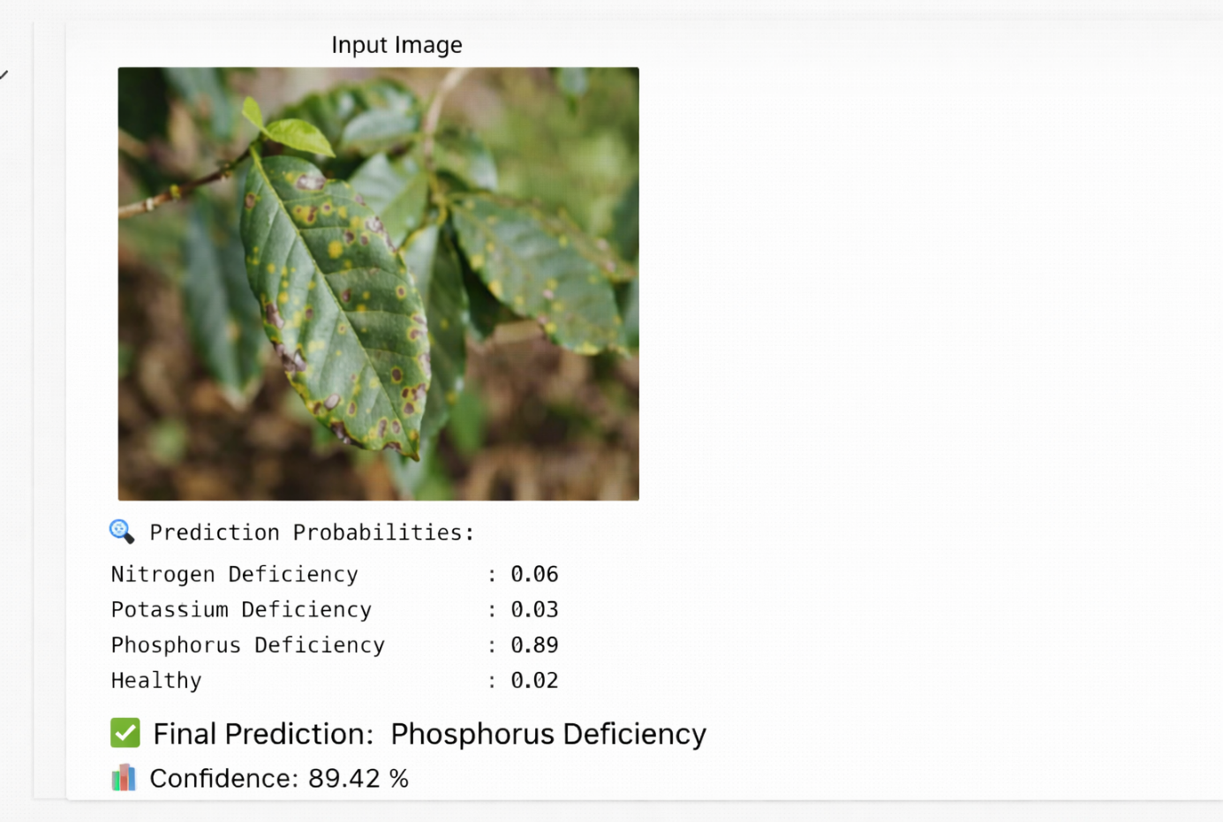
Figure (i) – Phosphorus Deficiency Detection
This output shows the prediction generated by the model using EfficientNetB4 for a diseased coffee leaf image. The input image contains visible symptoms such as dark brown spots with yellow halos spread across the leaf surface.The model processes the image and provides probability scores for each class. Among the four classes, Phosphorus Deficiency has the highest probability (0.89), leading to the final prediction. The confidence score of 89.42% indicates that the model is highly certain about this classification.This demonstrates the model’s ability to accurately identify nutrient deficiency patterns based on visual features like discoloration and lesion formation.

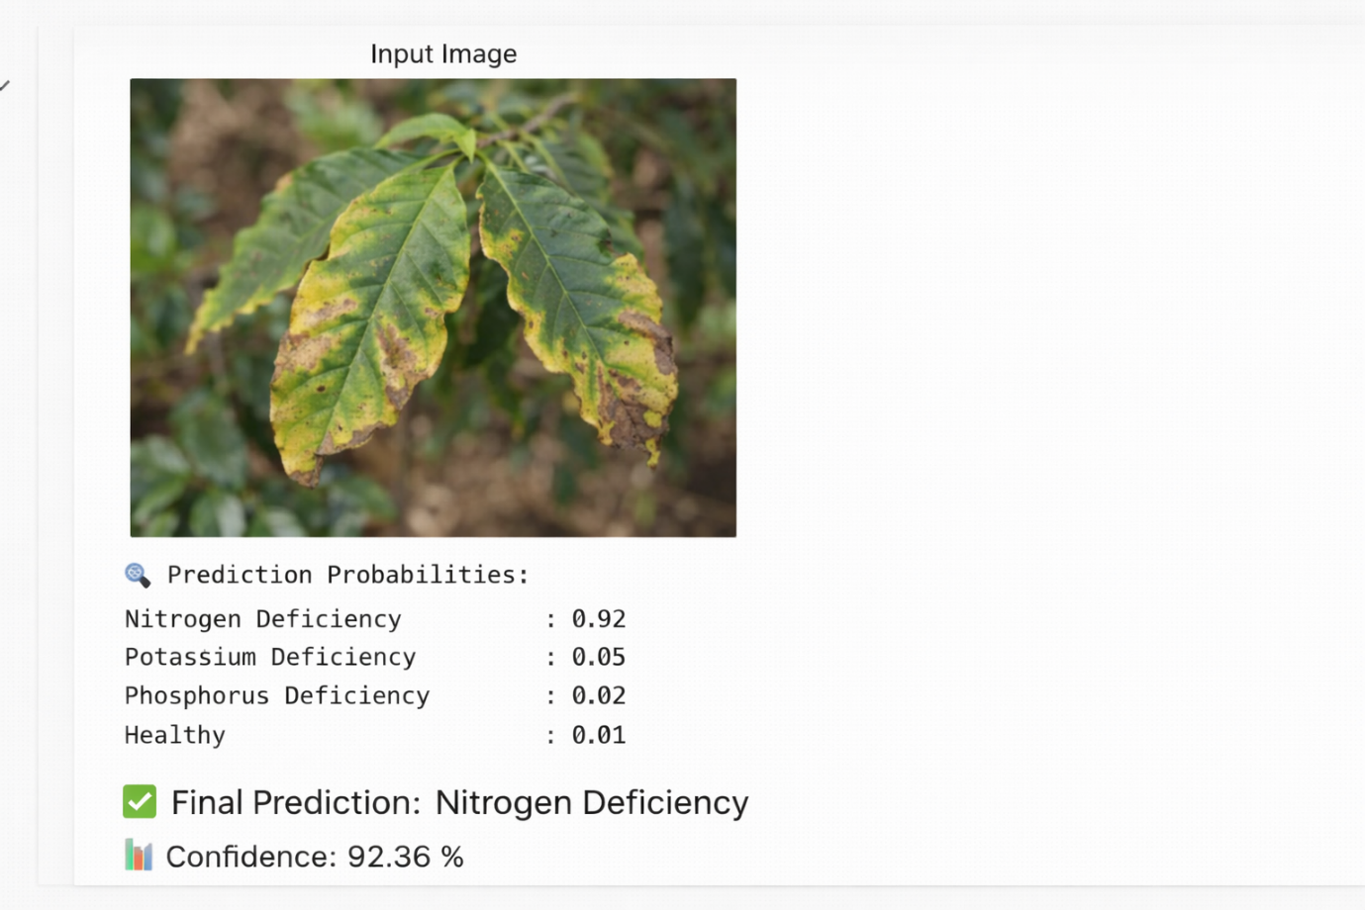
Figure (ii) – Nitrogen Deficiency Detection
In this output, the system analyzes a coffee leaf image showing symptoms such as yellowing of leaves (chlorosis) and drying edges. These are typical signs of nitrogen deficiency.The model assigns the highest probability (0.92) to Nitrogen Deficiency, compared to other classes. The final prediction is displayed along with a confidence score of 92.36%, indicating strong model reliability.This result highlights the effectiveness of transfer learning in enabling the model to detect nutrient stress conditions with high accuracy.
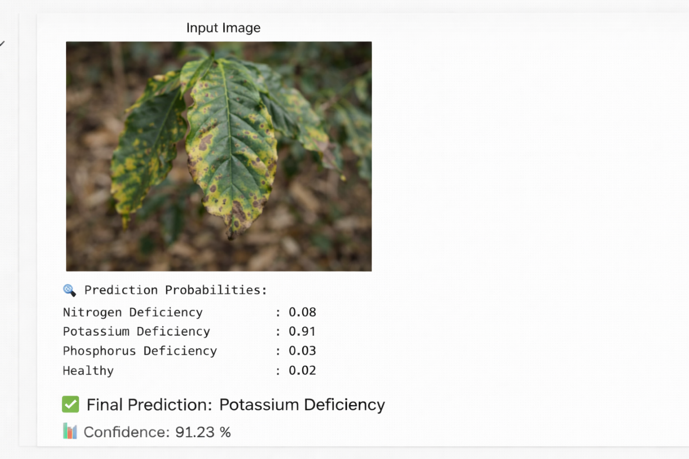

Figure (iii)– Potassium Deficiency Detection
This output represents the classification of another diseased coffee leaf image. The leaf shows symptoms like yellow patches, brown edges, and irregular spotting patterns, which are characteristic of potassium deficiency.The model outputs prediction probabilities for all classes and identifies Potassium Deficiency as the final class with the highest probability (0.91). The confidence score of 91.23% confirms the robustness of the prediction.This example demonstrates the model’s consistency in identifying different nutrient deficiencies across varied leaf conditions.

Discussion
The proposed Nutrient Deficiency Detection Model based on EfficientNetB4 demonstrates strong performance in accurately classifying coffee leaf images into different nutrient deficiency categories. The integration of transfer learning significantly reduced training time while improving feature extraction capability, as the model leverages pre-trained knowledge from large-scale datasets such as ImageNet.
The application of preprocessing and data augmentation techniques played a crucial role in enhancing model robustness. By normalizing image inputs and increasing dataset diversity through transformations such as rotation and flipping, the model was able to generalize better to unseen data and reduce overfitting. This is particularly important in agricultural datasets, where variations in lighting conditions, leaf orientation, and background noise are common.
EfficientNetB4 proved to be an effective backbone due to its compound scaling approach, which balances network depth, width, and resolution. This allowed the model to achieve higher accuracy with relatively lower computational complexity compared to traditional convolutional neural networks. Fine-tuning further improved performance by adapting the model to domain-specific features of coffee leaf deficiencies.
The classification results indicate that the model is capable of distinguishing between multiple nutrient deficiencies such as nitrogen, boron, and manganese, as well as identifying healthy leaves. However, some misclassifications may occur due to visual similarities between certain deficiency symptoms, overlapping features, or limited dataset size for specific classes.
Despite its effectiveness, the model has certain limitations. The performance is highly dependent on the quality and diversity of the dataset. In real-world scenarios, variations such as environmental conditions, occlusions, and image quality may affect prediction accuracy. Additionally, the model requires computational resources for training, which may limit its deployment on low-power devices.
Future improvements can include increasing dataset size, incorporating real-time image capture systems, and integrating attention mechanisms or hybrid models to further enhance accuracy. Deployment of the model as a mobile or web-based application can also make it more accessible for farmers and agricultural experts.
Overall, the proposed system provides an efficient and reliable approach for automated detection of nutrient deficiencies in coffee plants, contributing to precision agriculture and improved crop management practices.

Feature Extraction
Feature extraction is a critical stage in the proposed nutrient deficiency detection system, as it determines how effectively the model can identify important patterns from coffee leaf images. In this work, feature extraction is performed using the EfficientNetB4 deep learning model, which is known for its ability to capture both low-level and high-level image features with high accuracy. This approach eliminates the need for manual feature engineering and allows the model to learn directly from the data.Initially, the input images pass through multiple convolutional layers within the EfficientNetB4 architecture. These layers are responsible for detecting basic visual elements such as edges, shapes, and color variations. Such features are essential in identifying early signs of nutrient deficiencies, as different deficiencies often manifest as subtle changes in leaf color and texture.
As the data progresses through deeper layers of the network, more complex and abstract features are extracted. These include patterns related to leaf structure, vein distribution, and irregularities caused by nutrient deficiencies. The model learns to differentiate between healthy and affected leaves by identifying these distinctive characteristics, which improves its classification capability.
To further refine the extracted features, the model applies pooling operations that reduce the dimensionality of the feature maps while retaining important information. This step helps in minimizing computational complexity and prevents overfitting by removing redundant details. The resulting feature representation is compact yet highly informative.Overall, the use of EfficientNetB4 for feature extraction significantly enhances the performance of the system by providing robust and discriminative features. This enables the model to accurately classify different types of nutrient deficiencies in coffee plants, making it a reliable tool for agricultural analysis and decision-making.

Key Contributions
- Automated Nutrient Deficiency Detection System
This study proposes a fully automated system for detecting and classifying nutrient deficiencies in coffee plant leaves using deep learning techniques. The system minimizes human intervention and provides a faster, more consistent, and reliable alternative to traditional manual inspection methods used in agriculture.
- Adoption of EfficientNetB4 with Transfer Learning
The research effectively utilizes the EfficientNetB4 architecture combined with transfer learning to achieve high classification performance. By leveraging pre-trained weights from large-scale datasets, the model is able to capture complex visual patterns in leaf images while significantly reducing training time and computational requirements.
- Robust Preprocessing and Data Augmentation Strategy
A comprehensive preprocessing pipeline, including image resizing, normalization, and augmentation techniques such as rotation, flipping, and zooming, is implemented. This enhances dataset diversity and helps the model handle real-world variations like lighting conditions, background noise, and leaf orientation, thereby improving generalization.
- Accurate Multi-Class Classification of Deficiencies
The proposed system is designed to classify multiple categories, including various nutrient deficiencies such as nitrogen, boron, and manganese, as well as healthy leaves. This multi-class capability increases the practical applicability of the model in agricultural monitoring and decision-making processes.
- Enhanced Model Performance through Fine-Tuning and Regularization
Fine-tuning of the EfficientNetB4 layers allows the model to adapt specifically to coffee leaf characteristics, while regularization techniques such as dropout help prevent overfitting. These strategies collectively improve the stability, accuracy, and reliability of the model.
- Scalable Framework for Real-World Deployment
The proposed approach provides a scalable and flexible framework that can be extended to other crops and plant diseases. Furthermore, it has strong potential for deployment as a real-time mobile or web-based application, enabling farmers and agricultural experts to perform on-field diagnosis and improve crop management practices.

Advantages
- High Accuracy in Nutrient Deficiency Detection
The proposed model utilizes EfficientNetB4, which is known for its advanced architecture and compound scaling technique. This enables the model to capture both fine-grained and high-level features from coffee leaf images, resulting in highly accurate classification of different nutrient deficiencies. The ability to distinguish subtle variations in color and texture significantly improves diagnostic performance.
- Reduced Training Time through Transfer Learning
By adopting transfer learning, the model leverages pre-trained weights from large-scale datasets such as ImageNet. This reduces the need for extensive training from scratch and allows the model to converge faster. As a result, computational cost and training time are minimized while still maintaining high performance.
- Automation of the Detection Process
The system provides a fully automated approach to nutrient deficiency detection, eliminating the reliance on manual inspection by agricultural experts. This not only reduces human effort but also minimizes errors caused by subjective judgment, leading to more consistent and reliable results.
- Robustness to Real-World Variations
The integration of preprocessing and data augmentation techniques enhances the model’s ability to handle real-world challenges such as varying lighting conditions, different backgrounds, and changes in leaf orientation. This ensures that the model performs reliably even when deployed in practical agricultural environments.
- Multi-Class Classification Capability
Unlike traditional systems that focus on a single condition, the proposed model can classify multiple nutrient deficiencies, including nitrogen, boron, and manganese, along with healthy leaves. This comprehensive classification capability makes the system more useful for farmers and agricultural experts in diagnosing multiple issues simultaneously.
- Improved Generalization and Reduced Overfitting
Techniques such as dropout, normalization, and fine-tuning help in improving the generalization ability of the model. By preventing overfitting, the model performs well not only on training data but also on unseen test data, ensuring stable and reliable predictions.

Limitations
- Dependence on Dataset Quality and Diversity
The effectiveness of the proposed model is highly dependent on the quality, size, and diversity of the dataset used during training. If the dataset does not adequately represent different environmental conditions such as varying lighting, backgrounds, and leaf maturity stages, the model may fail to generalize well in real-world scenarios. Limited or biased datasets can lead to reduced robustness and lower prediction accuracy when deployed outside controlled conditions.
- Visual Similarity Between Nutrient Deficiencies
Many nutrient deficiencies in coffee leaves exhibit closely related visual symptoms, such as similar discoloration patterns, spotting, or texture changes. This overlap in visual features makes it challenging even for deep learning models to clearly distinguish between certain classes. As a result, the model may produce misclassifications, especially in borderline or ambiguous cases.
- Sensitivity to Image Quality and Environmental Noise
The model relies heavily on the quality of input images for accurate predictions. Images that are blurred, poorly lit, low-resolution, or affected by shadows and occlusions can negatively impact feature extraction. In real-world agricultural environments, where image capture conditions are not controlled, this limitation can significantly affect the reliability of the system.
- High Computational and Hardware Requirements
EfficientNetB4 is a complex deep learning architecture that requires substantial computational resources, particularly during the training phase. High-performance GPUs or cloud-based platforms are often necessary to train the model efficiently. This requirement can be a limitation for users with limited access to advanced hardware or computational infrastructure.
- Challenges in Real-Time Deployment
Although the model shows strong performance in a testing environment, deploying it in real-time applications such as mobile or edge devices presents challenges. The model may require optimization techniques such as model compression, pruning, or quantization to achieve faster inference speeds and lower memory usage for practical deployment.
- Limited Validation in Real-World Field Conditions
The model has primarily been evaluated on a curated dataset, which may not fully represent the complexity of real agricultural environments. Factors such as weather conditions, soil variations, and natural leaf damage may influence the appearance of leaves in ways not captured in the dataset. Therefore, extensive field-level testing is required to validate the model’s practical effectiveness.

Applications
- Precision Agriculture and Crop Management
The proposed system plays a significant role in precision agriculture by enabling accurate monitoring of nutrient deficiencies in coffee plants. By identifying deficiencies at an early stage, farmers can apply targeted fertilizers and corrective measures, which helps in optimizing resource usage, reducing waste, and improving overall crop yield and quality. This leads to more efficient and sustainable farming practices.
- Integration with Smart Farming Technologies
The model can be integrated with advanced smart farming systems, including IoT-based sensors, automated irrigation systems, and nutrient management platforms. By combining image-based analysis with sensor data, farmers can gain a comprehensive understanding of plant health and environmental conditions, enabling data-driven and automated decision-making processes.
- Mobile and Web-Based Agricultural Applications
The system can be deployed as a mobile or web-based application, allowing users to upload or capture images of coffee leaves and receive instant predictions. This makes the technology highly accessible, especially for farmers in rural or remote areas who may not have easy access to agricultural experts. Such applications can significantly reduce the time required for diagnosis and improve farm productivity.
- Support for Agricultural Extension Services
Agricultural extension officers and field experts can use this system as a decision-support tool to provide accurate and timely recommendations to farmers. It enhances advisory services by offering reliable diagnostic results, which can help farmers adopt appropriate nutrient management strategies and improve crop health.
- Research and Data Analysis in Agriculture
The model can be utilized by researchers to analyze patterns of nutrient deficiencies across different regions, climates, and soil conditions. It can assist in identifying trends, studying the impact of environmental factors on plant health, and developing improved agricultural techniques and policies.
- Early Warning and Preventive Systems
The ability of the model to detect nutrient deficiencies at an early stage makes it an effective early warning system. Farmers can take preventive measures before the deficiency becomes severe, thereby reducing crop losses and ensuring better plant growth and productivity.

Conclusion
In this work, an efficient and automated system for the detection and classification of nutrient deficiencies in coffee plant leaves has been successfully developed using the EfficientNetB4 deep learning model. The integration of transfer learning and fine-tuning techniques enabled the model to effectively learn both general and domain-specific features, resulting in improved classification performance. The use of preprocessing and data augmentation further enhanced the robustness and generalization capability of the system.The proposed model demonstrated its ability to accurately identify multiple nutrient deficiencies such as nitrogen, boron, and manganese, along with healthy leaves. By leveraging advanced feature extraction capabilities, the system was able to distinguish subtle variations in leaf color, texture, and patterns, which are critical indicators of plant health. This highlights the effectiveness of deep learning approaches in agricultural applications.Moreover, the system offers a practical and time-efficient alternative to traditional manual inspection methods. It reduces human effort, minimizes errors, and provides faster diagnosis, making it highly beneficial for farmers and agricultural experts. The potential integration of the model into mobile or web-based platforms further enhances its usability in real-world scenarios.Despite certain limitations such as dependency on dataset quality and computational requirements, the overall performance of the model indicates its reliability and effectiveness. With further improvements and real-world validation, the system can be extended to support a wider range of crops and plant diseases.In conclusion, the proposed approach contributes significantly to the field of precision agriculture by providing an accurate, scalable, and efficient solution for nutrient deficiency detection in coffee plants. It has strong potential to support better crop management practices and improve agricultural productivity.

Future Work
The proposed nutrient deficiency detection model demonstrates promising results; however, several directions can be explored to further enhance its performance and practical applicability. One of the primary areas for future work is the expansion of the dataset by including a larger number of coffee leaf images collected under diverse environmental conditions such as varying lighting, backgrounds, and growth stages. A more diverse dataset will improve the model’s robustness and generalization capability in real-world scenarios.Another important direction is the incorporation of advanced deep learning techniques, such as attention mechanisms or hybrid models that combine convolutional neural networks with transformer-based architectures. These approaches can help the model focus on the most relevant regions of the leaf, thereby improving the accuracy of nutrient deficiency detection, especially in cases where symptoms are subtle or overlapping.
Future work can also focus on optimizing the model for real-time deployment on mobile and edge devices. Techniques such as model pruning, quantization, and compression can be applied to reduce computational complexity and improve inference speed, making the system more accessible and practical for farmers in field conditions.In addition, the system can be extended to detect a wider range of plant health issues, including diseases, pest infestations, and environmental stress factors. Developing a unified model capable of handling multiple plant conditions will significantly increase its utility in agricultural applications.Another promising direction is the integration of the model with IoT-based smart farming systems. By combining image-based analysis with sensor data such as soil moisture, temperature, and nutrient levels, a more comprehensive and intelligent crop monitoring system can be developed.
Finally, future research can explore the use of explainable AI techniques, such as Grad-CAM, to improve the interpretability of the model. This will help users understand how predictions are made and increase trust in the system, especially among farmers and agricultural experts.

References:
1.Soares, C. C., Regazzo, J. R., Silva, T. L. D., Silva Tavares, M., Devechio, F. D. F. D. S., Martins Silva, R., ... & Baesso, M. M. (2026). Applications of Machine Learning and Deep Learning for Foliar Nutritional Deficiency: A Systematic Review. AgriEngineering, 8(3), 101.
DOI:https://doi.org/10.3390/agriengineering8030101
2. Poolakanda Somanna, H. (2025). A Deep Learning-Based System for Plant Disease Detection and Classification in Arabica Coffee Leaves (Doctoral dissertation, Dublin, National College of Ireland).DOI: https://doi.org/10.34306/conferenceseries.v4i1.627
3. Mridul, A. H., Armin, J. F., Saleh, M. A., Das, A., Islam, M. M., Shakil, G. M., & Rakib, M. A. (2025, November). Optimizing Rice Health: A Comparative Evaluation of Pretrained and Custom Convolutional Neural Networks for Disease Recognition. In Artificial Intelligence and Applications.DOI: https://doi.org/10.47852/bonviewAIA52026109
4. Bacuna, R. D., & Ballera, M. A. (2025). iCLAS: Leaf-Based Classification Model Using EfficientNet for Optimizing Intercropping Farm Methods. In Computer and Electrical Engineering: Proceedings of the 18th International Conference on Computer and Electrical Engineering (ICCEE 2025), Singapore, 20-22 June 2025 (pp. 39-46). 1 Oliver's Yard, 55 City Road, London, EC1Y 1SP: SAGE Publications.
https://doi.org/10.3233/ATDE250725
5. Chavan, K. A. (2025). CROP DISEASE DETECTION WITH DEEP LEARNING: A SURVEY OF MODERN APPROACHES. International Journal of Applied Mathematics, 38(1s), 1482-1508. DOI: https://doi.org/10.12732/ijam.v38i1s.1065
6. Goyal, S. B., Malik, V., Rajawat, A. S., Khan, M., Ikram, A., Alabdullah, B., & Almjally, A. (2025). Smart intercropping system to detect leaf disease using hyperspectral imaging and hybrid deep learning for precision agriculture. Frontiers in Plant Science, 16, 1662251. https://doi.org/10.3389/fpls.2025.1662251
7. Winarno, E., Solichan, A., Ramdani, A. P., Hadikurniawati, W., Septiarini, A., & Hamdani, H. (2025). Enhanced Semarang batik classification using deep learning: a comparative study of CNN architectures. Bulletin of Electrical Engineering and Informatics, 14(5), 3544-3557. DOI: https://doi.org/10.11591/eei.v14i5.9347
8. Alahi, T. E., Dip, S. D., Mojumdar, M. U., Chakraborty, N. R., & Haldar, N. (2025, April). Image-Based Diagnosis of Bean Plant Health: detection and classification of diseases on beans leaves. In 2025 12th International Conference on Computing for Sustainable Global Development (INDIACom) (pp. 1-5). IEEE. DOI: 10.23919/INDIACom66777.2025.11115399
9. Rosadi, M. I., & Hakim, L. (2023, December). Classification of coffee leaf diseases using the convolutional neural network (CNN) efficientnet model. In IAIC International Conference Series (Vol. 4, No. 1, pp. 58-69). DOI: https://doi.org/10.34306/conferenceseries.v4i1.627
10. Pratap, V. K., & Kumar, N. S. (2023). High-precision multiclass classification of chili leaf disease through customized EffecientNetB4 from chili leaf images. Smart Agricultural Technology, 5, 100295.
https://doi.org/10.1016/j.atech.2023.100295
11. Puspasari, B. D., Chang, I. C., Pramono, A., & Yulianti, T. (2024, November). EfficientNet-based sugarcane disease classification with dual-convolution spatial attention CBAM (EfficientNet-DCCBAM). In 2024 IEEE International Conference on Communication, Networks and Satellite (COMNETSAT) (pp. 1-6). IEEE.
DOI: 10.1109/COMNETSAT63286.2024.10862924
12. Sharma, M., Kumar, C. J., Singh, T. P., Talukdar, J., Sharma, R. K., & Ganguly, A. (2023). Enhancing disease region segmentation in rice leaves using modified deep learning architectures. Archives of Phytopathology and Plant Protection, 56(20), 1555-1580.
https://doi.org/10.1080/03235408.2024.2310326

13. Vera, O., Cruz, J., Huaquipaco, S., Mamani, W., Yana-Mamani, V., & Huaquipaco, S. (2024). Automated and Enhanced Classification of Persea Americana Using Optimized Deep Convolutional Neural Networks With Improved Training Strategies for Agro-Industrial Settings. IEEE Access, 12, 194240-194255. DOI: 10.1109/ACCESS.2024.3496728
14. Ranga, S., Sheoran, S. K., & Singh, G. (2024, September). Leaf Diseases Detection in Peach Using EfficientNet. In International Conference on Electronic Governance with Emerging Technologies (pp. 109-121). Cham: Springer Nature Switzerland.
15. Bacuna, R. D., & Ballera, M. A. (2025). iCLAS: Leaf-Based Classification Model Using EfficientNet for Optimizing Intercropping Farm Methods. In Computer and Electrical Engineering: Proceedings of the 18th International Conference on Computer and Electrical Engineering (ICCEE 2025), Singapore, 20-22 June 2025 (pp. 39-46). 1 Oliver's Yard, 55 City Road, London, EC1Y 1SP: SAGE Publications.
https://doi.org/10.3233/ATDE250725
16. Lelis, A. K., Ferriols, E. G. I., Vallesteros, K. M. A., & Delmo, J. A. B. (2023, June). A comparative analysis of convolutional neural network architectures for coffee leaf rust detection. In 2023 IEEE International Conference on Automatic Control and Intelligent Systems (I2CACIS) (pp. 213-218). IEEE. DOI: 10.1109/I2CACIS57635.2023.10193074
17. Goyal, S. B., Malik, V., Rajawat, A. S., Khan, M., Ikram, A., Alabdullah, B., & Almjally, A. (2025). Smart intercropping system to detect leaf disease using hyperspectral imaging and hybrid deep learning for precision agriculture. Frontiers in Plant Science, 16, 1662251.
https://doi.org/10.3389/fpls.2025.1662251
18. Balafas, V., Karantoumanis, E., Louta, M., & Ploskas, N. (2023). Machine learning and deep learning for plant disease classification and detection. IEEE Access, 11, 114352-114377. DOI: 10.1109/ACCESS.2023.3324722
19. Maula, I. M. (2025). Machine Learning-Based Disease Detection in Cocoa Plantations: Economic Viability Study in Luwu Regency, South Sulawesi. Journal of Agricultural Economy and Technology Development, 2(2), 30-55. DOI:
https://doi.org/10.59261/jaetd.v2i2.42
20. Santos, D. M. (2022). Redes neurais convolucionais para classificar a maturação de frutos de café. http://doi.org/10.14393/ufu.di.2021.359
21. Calderón-Mosilot, C., Tapia-Gálvez, U., Arcila-Diaz, J., & Mejia-Cabrera, H. I. (2025). Diagnosis of Nutritional Deficiencies in Coffee Plants Through Automated Analysis of Digital Images Using Deep Learning in Uncontrolled Agricultural Environments. AgriEngineering, 7(12), https://doi.org/10.3390/agriengineering7120421
22. Randive, L., Sapkal, S., & Bornare, D. (2025). Nutrient deficiency detection and classification in coffee leaves using deep learning models. In EPJ Web of Conferences (Vol. 328, p. 01038). EDP Sciences.
https://doi.org/10.1051/epjconf/202532801038
23. Istoningtyas, M., Manongga, D., & Nataliani, Y. (2025, August). Enhancing Agricultural Productivity through Automated Detection of Coffee Leaf Nutrient Deficiencies. In 2025 4th International Conference on Creative Communication and Innovative Technology (ICCIT) (pp. 1-7). IEEE. DOI: 10.1109/ICCIT65724.2025.11166773
24. Chellamanı, U., & Kaliaperumal, B. (2025). A Deep Learning Model for Detection and Classification of Nutritional Deficiency in Coffee Plant. Journal of Agricultural Sciences, 31(4), 960-980. https://doi.org/10.15832/ankutbd.1568929
25. Calderón-Mosilot, C., Tapia-Gálvez, U., Arcila-Diaz, J., & Mejia-Cabrera, H. I. (2025). Diagnosis of Nutritional Deficiencies in Coffee Plants Through Automated Analysis of Digital Images Using Deep Learning in Uncontrolled Agricultural Environments. AgriEngineering, 7(12), https://doi.org/10.3390/agriengineering7120421

